# **Big Data Programming**

**Project Increment 1 Report**

**Title:**

**Team Members:**

Prakhya Srungarapu - [psrv7@mail.umkc.edu](mailto:psrv7@mail.umkc.edu)

Sai Saranya Vipparla - [svv7x@mail.umkc.edu](mailto:svv7x@mail.umkc.edu)

Vamshi Krishna Routhu - [nrqnh@mail.umkc.edu](mailto:nrqnh@mail.umkc.edu)

Shiva Kumar Murarishetti – [smpf4@mail.umkc.edu](mailto:smpf4@mail.umkc.edu)

**Introduction:**

**Background:**

**Goals and Objectives**

**Motivation:**

**Objectives:**

**Features:**

**Significance:**

**Dataset:**

**Workflow:**

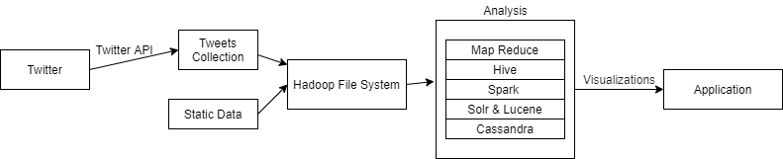

**Analysis:**

**Implementation:**

**Project Management:**

Implementation Status Report:

Work Completed:

* Documenting and Downloading the data batch from twitter
* Data Implementation & Data preprocessing along with documenting it
* Queries executing and report of that

Work to be Completed:

* Spark Sql Queries, Data Frames, and visualizations.
* Sentimental Analyzation (TextBlob)
* Solr Queries and Graph frames on the twitter data.
* Hosting on a Web Application.

**Story Telling:**

**Who:**

**What:**

**When:**

**Where:**

**Why:**

**References:**